



**Disclaimer: The content is curated from online/offline resources and used for educational purpose only**

**LAB MANUAL**

**Unit III – Machine Learning**

**Unit III – Machine Learning**

**Lab 1. Implementation of linear regression in Excel using CO2 emissions dataset**

**Objective**

The objective of this project is to implement Linear Regression in Excel using a CO2 Emissions dataset. The goal is to predict the CO2 Emissions based on a corresponding variable, such as Industrial Activity, and analyze the relationship between these variables using a linear regression model.

**Problem**

To implement Linear Regression in Excel using a CO2 Emissions Dataset, follow the steps below. We will assume you have a dataset with CO2 emissions data along with a corresponding variable.

**Solution**

To predict solar power output using linear regression and save the model, we'll go through the following steps:

1. Insert a Scatter Plot
   * Highlight the data range for the independent variable (Industrial Activity) and dependent variable (CO2 Emissions)
   * Go to the Insert tab in the Excel ribbon.
   * In the Charts group, click on Insert Scatter (X, Y) or Bubble Chart.
   * Choose Scatter with Straight Lines or Scatter with Markers to display the data points.
2. Add a Trendline (Linear Regression)
   * Right-click on any data point in the scatter plot.
   * Click Add Trendline.
   * In the Format Trendline pane, do the following:
   * Select Linear for the type of trendline.
   * Check Display Equation on chart.
   * Check Display R-squared value on chart.
   * To predict future CO2 emissions

**Procedures**

**1. Insert a Scatter Plot**

1. Highlight the data range for the independent variable (Industrial Activity) and dependent variable (CO2 Emissions)

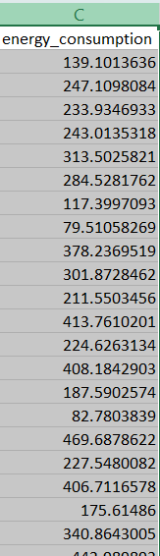

1. Go to the Insert tab in the Excel ribbon.



1. In the Charts group, click on Insert Scatter (X, Y) or Bubble Chart.

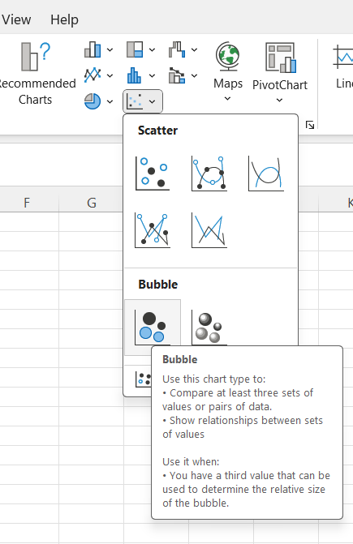

1. Choose Scatter with Straight Lines or Scatter with Markers to display the data points.

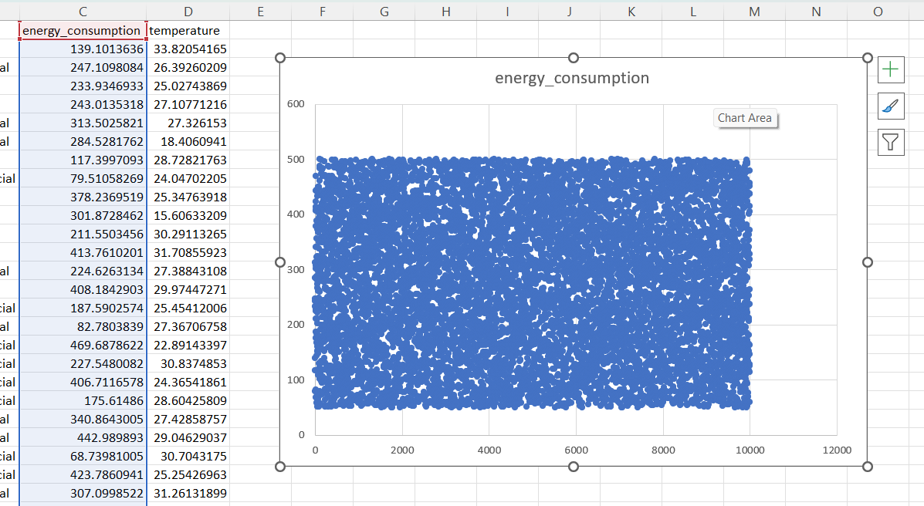

**2. Add a Trendline (Linear Regression)**

1. Right-click on any data point in the scatter plot.

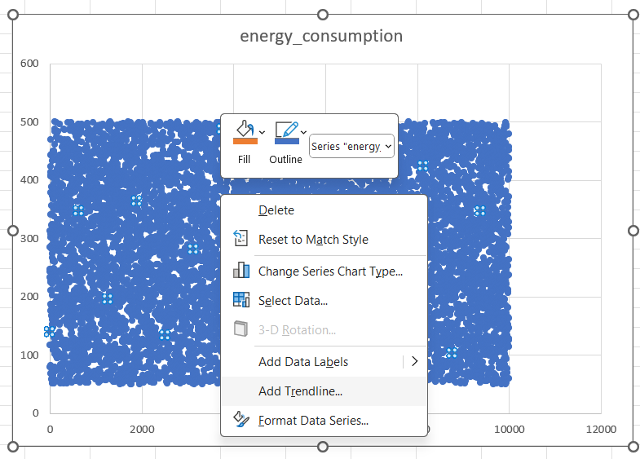

1. Click Add Trendline.

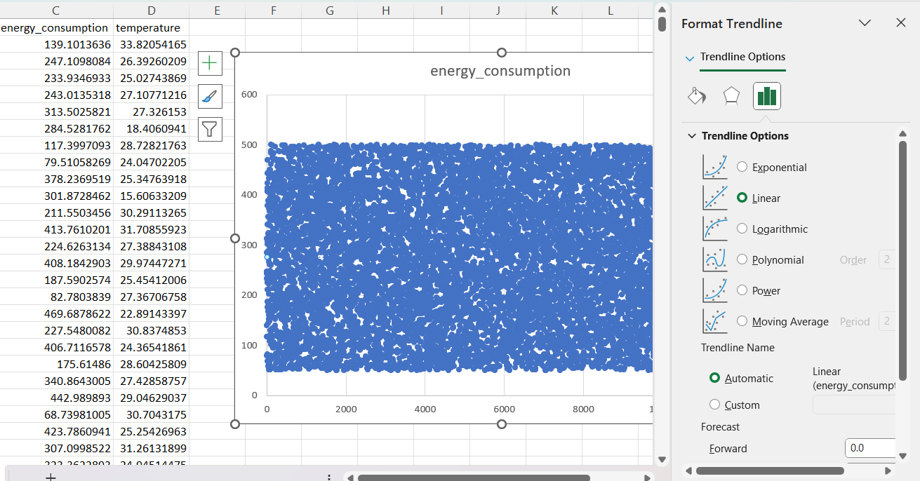

1. In the Format Trendline pane, do the following:
   * Select Linear for the type of trendline.

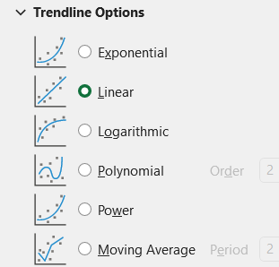

* + Check Display Equation on chart.

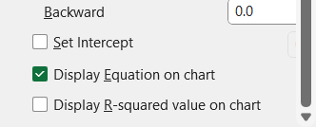

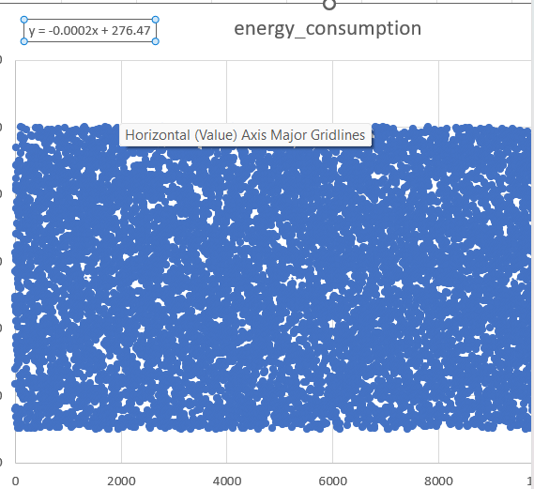

* + Check Display R-squared value on chart.

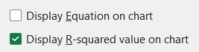

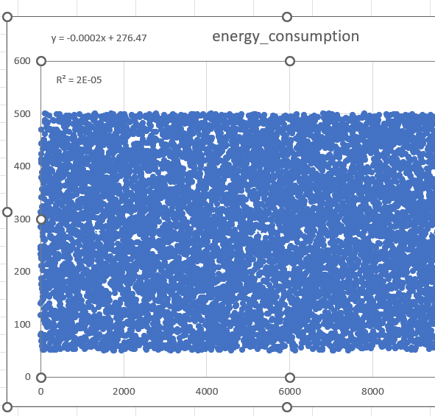

The trendline (linear regression) will be added to your scatter plot, showing the regression equation and R-squared value.

**Predict Future CO2 Emissions**

To predict future CO2 emissions, use the regression equation that Excel displays on the chart.

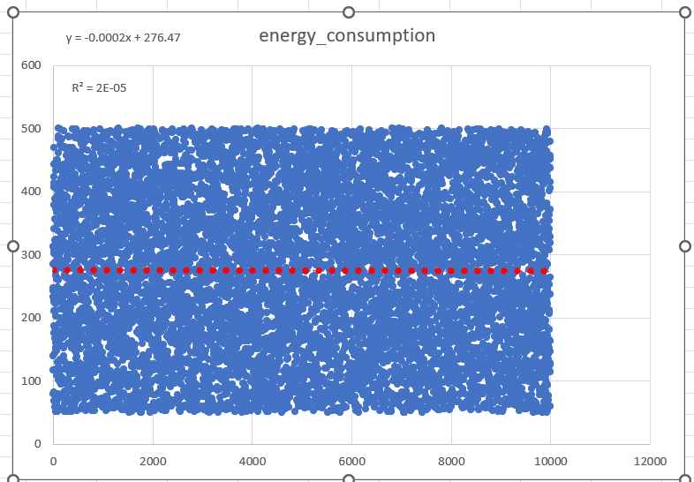

y = -0.0002x + 276.47

R² = 2E-05